**Ideation Phase**

**Brainstorm & Idea Prioritization**

|  |  |
| --- | --- |
| Date | 09 September 2022 |
| Team ID | PNT2022TMID05121 |
| Project Name | Iot Based Smart Crop Protection System for Agriculture |
| Maximum Mark | 4 Marks |

**Step-1: Team Gathering, Collaboration and select the Problem Statement**

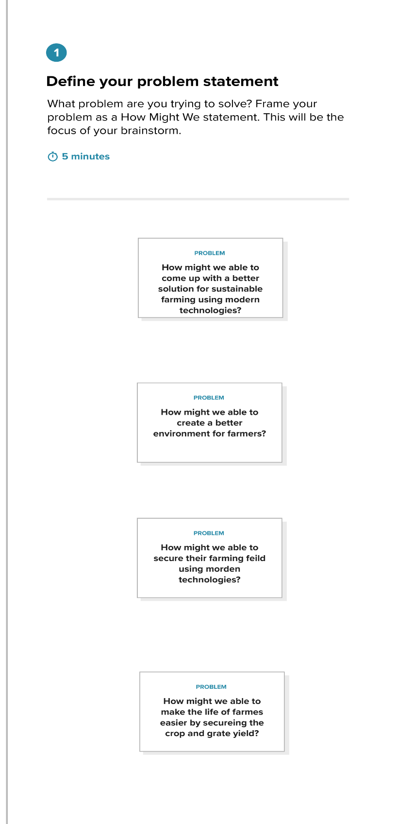

**Step-2: Brainstorm, Idea listing and Grouping**

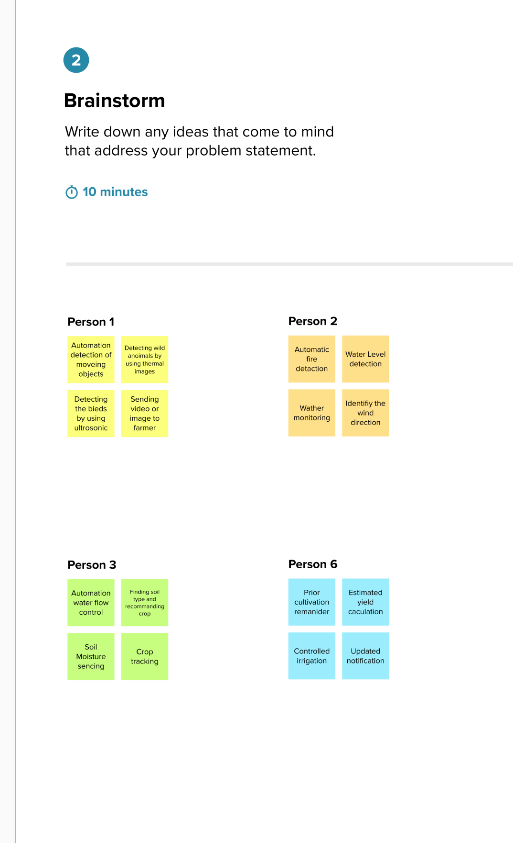

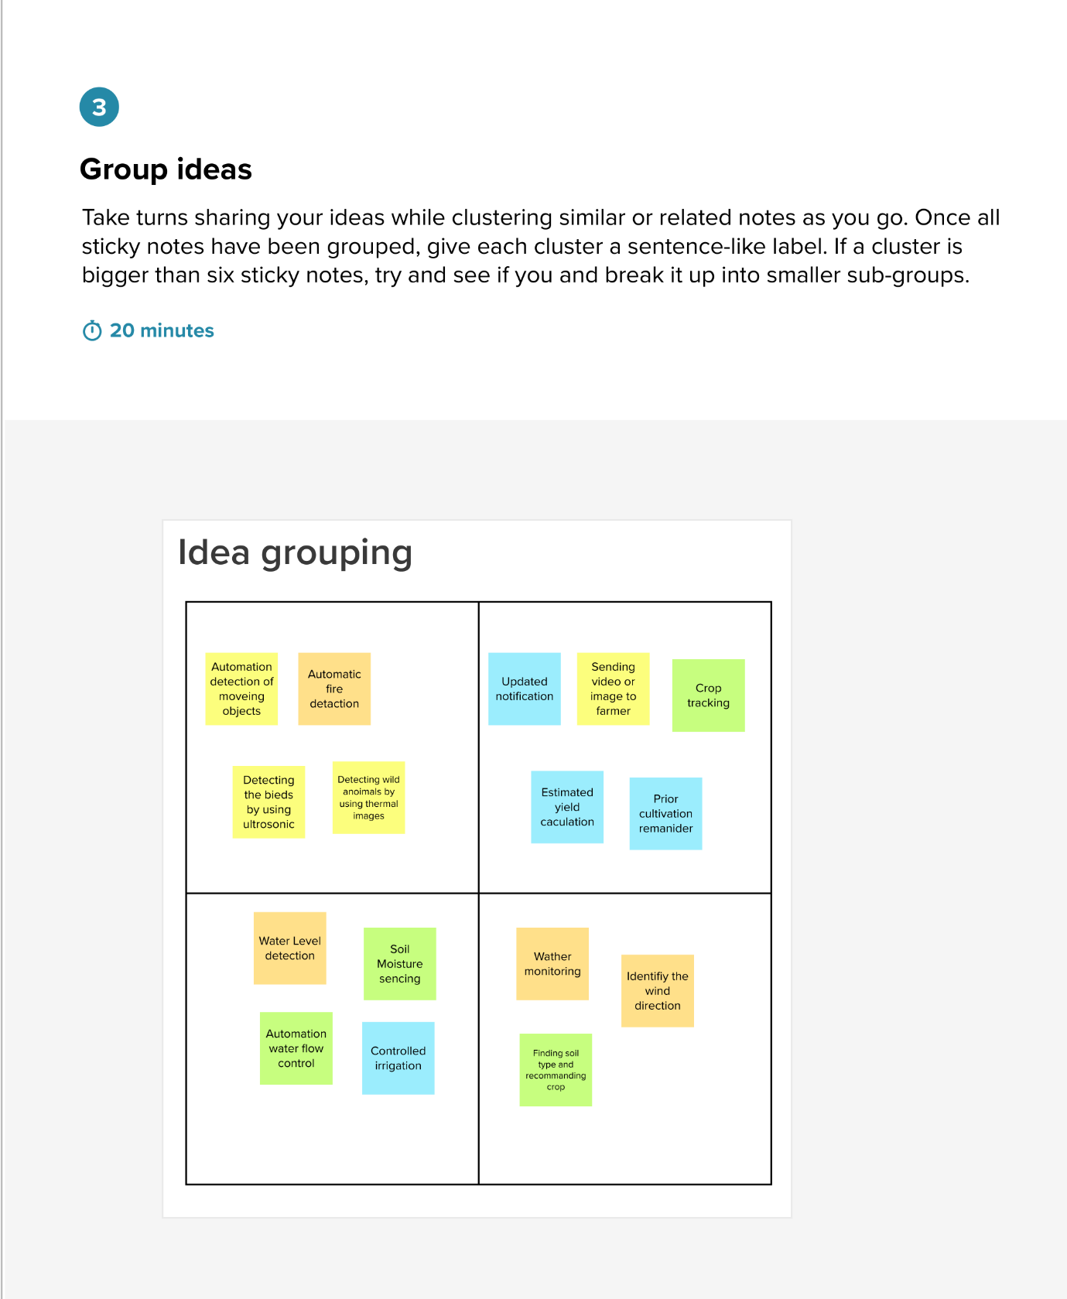

**Step-3: Idea Prioritization**

